Chapter 14: SOLUTIONS TO TEXT PROBLEMS:

Quick Quizzes

1. When a competitive firm doubles the amount it sells, the price remains the same, so its total revenue doubles.

2. The price faced by a profit-maximizing firm is equal to its marginal cost because if price were above marginal cost, the firm could increase profits by increasing output, while if price were below marginal cost, the firm could increase profits by decreasing output.

A profit-maximizing firm decides to shut down in the short run when price is less than average variable cost. In the long run, a firm will exit a market when price is less than average total cost.

3. In the long run, with free entry and exit, the price in the market is equal to both a firm’s marginal cost and its average total cost, as Figure 1 shows. The firm chooses its quantity so that marginal cost equals price; doing so ensures that the firm is maximizing its profit. In the long run, entry into and exit from the industry drive the price of the good to the minimum point on the average-total-cost curve.

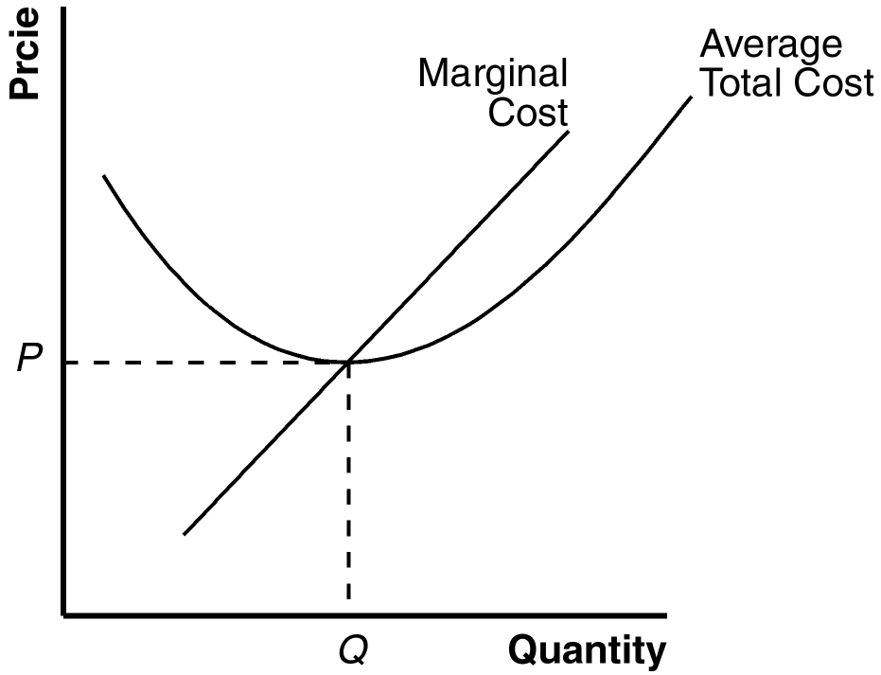

Figure 1

Questions for Review

1. A competitive firm is a firm in a market in which: (1) there are many buyers and many sellers in the market; (2) the goods offered by the various sellers are largely the same; and (3) usually firms can freely enter or exit the market.

2. Figure 2 shows the cost curves for a typical firm. For a given price (such as P*), the level of output that maximizes profit is the output where marginal cost equals price (Q*), as long as price is greater than average variable cost at that point (in the short run), or greater than average total cost (in the long run).

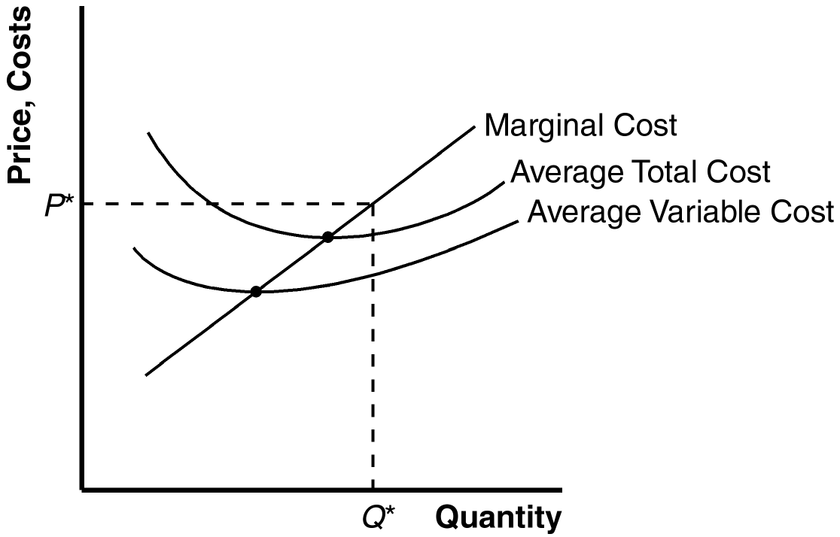

Figure 2

3. A firm will shut down temporarily if the revenue it would get from producing is less than the variable costs of production. This occurs if price is less than average variable cost.

4. A firm will exit a market if the revenue it would get if it stayed in business is less than its total cost. This occurs if price is less than average total cost.

5. A firm's price equals marginal cost in both the short run and the long run. In both the short run and the long run, price equals marginal revenue. The firm should increase output as long as marginal revenue exceeds marginal cost, and reduce output if marginal revenue is less than marginal cost. Profits are maximized when marginal revenue equals marginal cost.

6. The firm's price equals the minimum of average total cost only in the long run. In the short run, price may be greater than average total cost, in which case the firm is making profits, or price may be less than average total cost, in which case the firm is making losses. But the situation is different in the long run. If firms are making profits, other firms will enter the industry, which will lower the price of the good. If firms are making losses, they will exit the industry, which will raise the price of the good. Entry or exit continues until firms are making neither profits nor losses. At that point, price equals average total cost.

7. Market supply curves are typically more elastic in the long run than in the short run. In a competitive market, since entry or exit occurs until price equals the minimum of average total cost, the supply curve is perfectly elastic in the long run.

Problems and Applications

1. A competitive market is one in which: (1) there are many buyers and many sellers in the market; (2) the goods offered by the various sellers are largely the same; and (3) usually firms can freely enter or exit the market. Of these goods, bottled water is probably the closest to a competitive market. Tap water is a natural monopoly because there's only one seller. Cola and beer are not perfectly competitive because every brand is slightly different.

2. Since a new customer is offering to pay $300 for one dose, marginal revenue between 200 and 201 doses is $300. So we must find out if marginal cost is greater than or less than $300. To do this, calculate total cost for 200 doses and 201 doses, and calculate the increase in total cost. Multiplying quantity by average total cost, we find that total cost rises from $40,000 to $40,401, so marginal cost is $401. So your roommate should not make the additional dose.

3. a. Remembering that price equals marginal cost when firms are maximizing profit, we know the marginal cost must be 30 cents, since that is the price.

b. The industry is not in long-run equilibrium since price exceeds average total cost.

4. Once you have ordered the dinner, its cost is sunk, so it does not represent an opportunity cost. As a result, the cost of the dinner should not influence your decision about stuffing yourself.

5. Since Bob’s average total cost is $280/10 = $28, which is greater than the price, he will exit the industry in the long run. Since fixed cost is $30, average variable cost is ($280 - $30)/10 = $25, which is less than price, so Bob won’t shut down in the short run.

6. Here’s the table showing costs, revenues, and profits:

Quantity | Total Cost | Marginal Cost | Total Revenue | Marginal Revenue | Profit
0 | $ 8 | --- | $ 0 | --- | $ -8
1 | 9 | $ 1 | 8 | $ 8 | -1
2 | 10 | 1 | 16 | 8 | 6
3 | 11 | 1 | 24 | 8 | 13
4 | 13 | 2 | 32 | 8 | 19
5 | 19 | 6 | 40 | 8 | 21
6 | 27 | 8 | 48 | 8 | 21
7 | 37 | 10 | 56 | 8 | 19

a. The firm should produce 5 or 6 units to maximize profit.

b. Marginal revenue and marginal cost are graphed in Figure 3. The curves cross at a quantity between 5 and 6 units, yielding the same answer as in part (a).

c. This industry is competitive since marginal revenue is the same for each quantity. The industry is not in long-run equilibrium, since profit is positive.

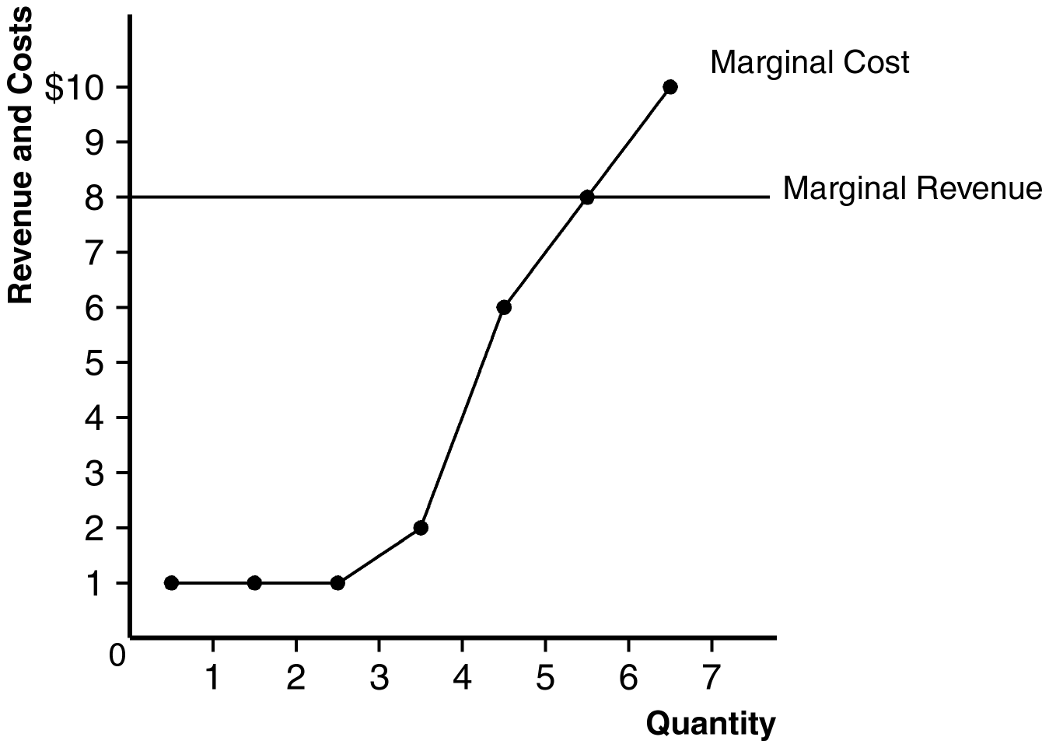

Figure 3

7. a. Figure 4 shows the short-run effect of declining demand for beef. The shift of the industry demand curve from D₁ to D₂ reduces the quantity from Q₁ to Q₂ and reduces the price from P₁ to P₂. This affects the firm, reducing its quantity from q₁ to q₂. Before the decline in the price, the firm was making zero profits; afterwards, profits are negative, as average total cost exceeds price.

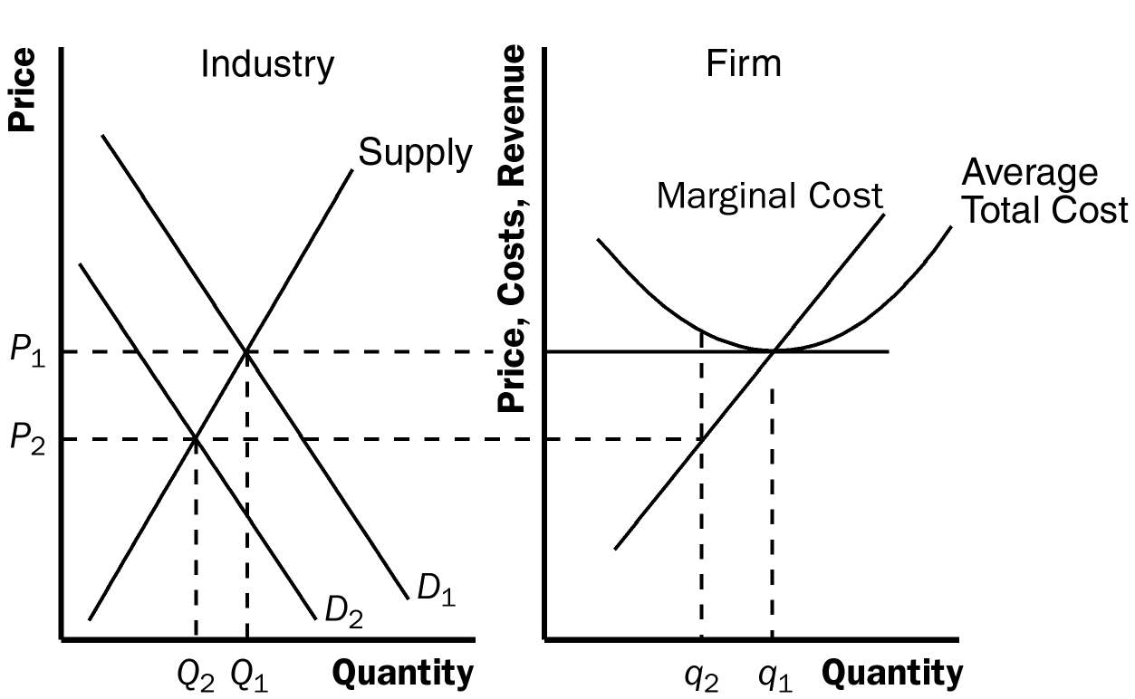

Figure 4

b. Figure 5 shows the long-run effect of declining demand for beef. Since firms were losing money in the short run, some firms leave the industry. This shifts the supply curve from S₁ to S₃. The shift of the supply curve is just enough to increase the price back to its original level, P₁. As a result, industry output falls still further, to Q₃. For firms that remain in the industry, the rise in the price to P₁ returns them to their original situation, producing quantity q₁ and earning zero profits.

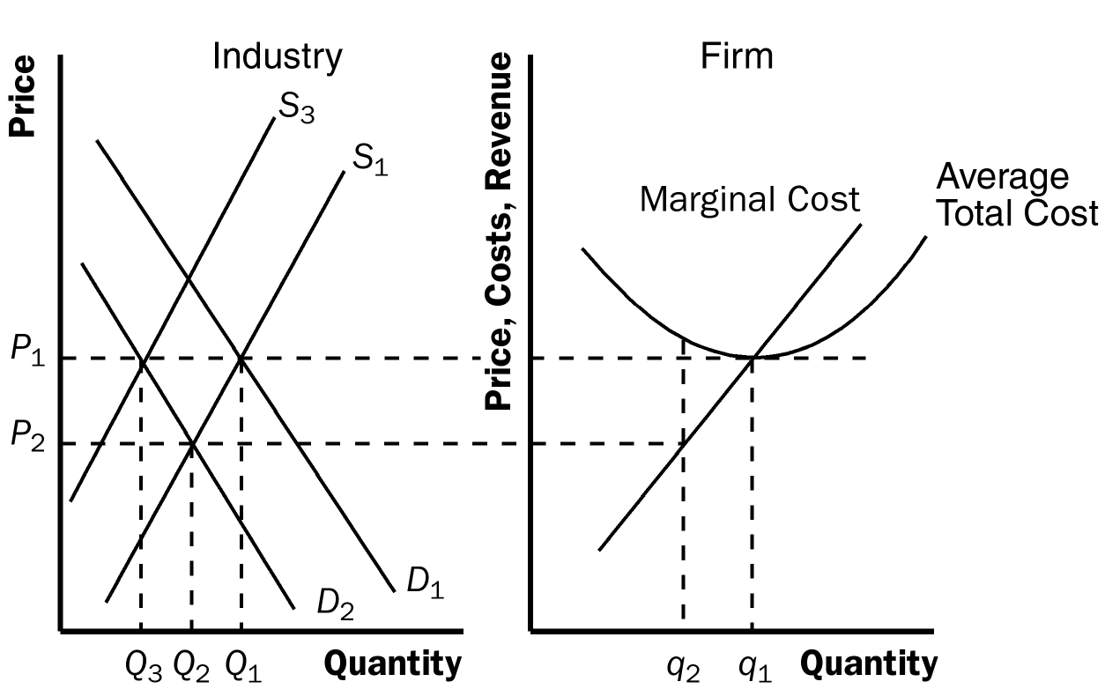

Figure 5

8. Figure 6 shows that although high prices cause an industry to expand, entry into the industry eventually returns prices to the point of minimum average total cost. In the figure, the industry is originally in long-run equilibrium. The industry produces output Q₁, where supply curve S₁ intersects demand curve D₁, and the price is P₁. At this point the typical firm produces output q₁. Since price equals average total cost at that point, the firm makes zero economic profit.

Now suppose an increase in demand occurs, with the demand curve shifting to D₂. This causes "high prices" in the industry, as the price rises to P₂. It also causes the industry to increase output to Q₂. With the higher price, the typical firm increases its output from q₁ to q₂, and now makes positive profits, since price exceeds average total cost.

However, the positive profits that firms earn encourage other firms to enter the industry. Their entry, "an expansion in an industry," leads the supply curve to shift to S₃. The new equilibrium reduces the price back to P₁, "bringing an end to high prices and manufacturers' prosperity," since now firms produce q₁ and earn zero profit again. The only long-lasting effect is that industry output is Q₃, a higher level than originally.

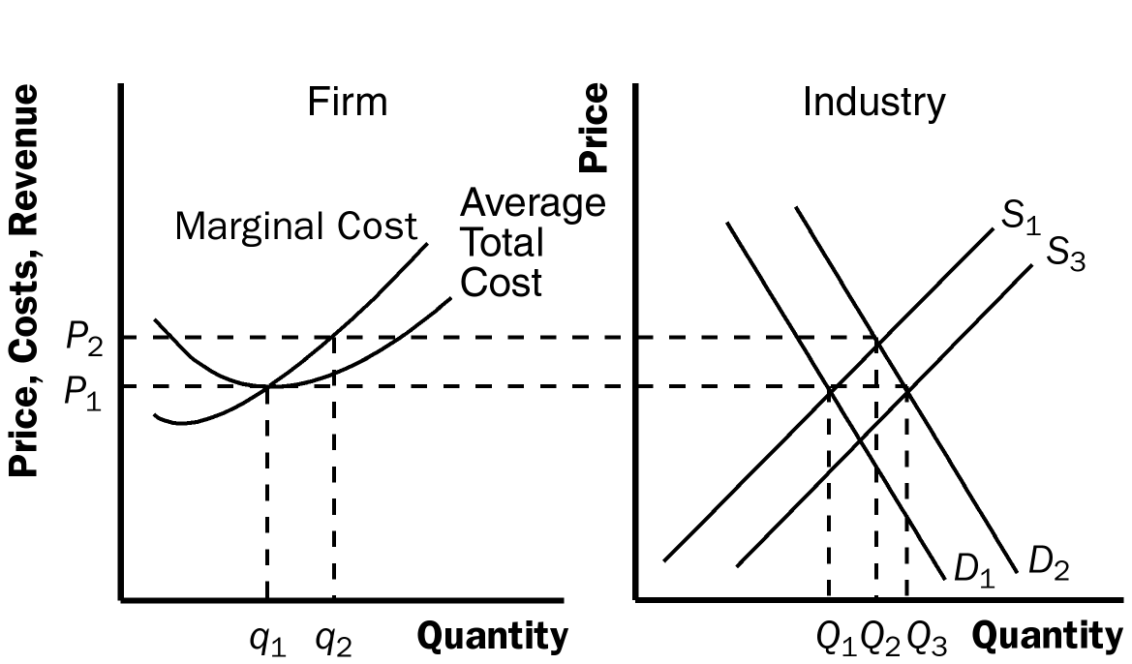

Figure 6
9. a. Figure 7 shows the typical firm in the industry, with average total cost ATC₁, marginal cost MC₁, and price P₁.

b. The new process reduces Hi-Tech’s marginal cost to MC₂ and its average total cost to ATC₂, but the price remains at P₁ since other firms cannot use the new process. Thus Hi-Tech earns positive profits.

c. When the patent expires and other firms are free to use the technology, all firms’ average-total-cost curves decline to ATC₂, so the market price falls to P₃ and firms earn no profits.

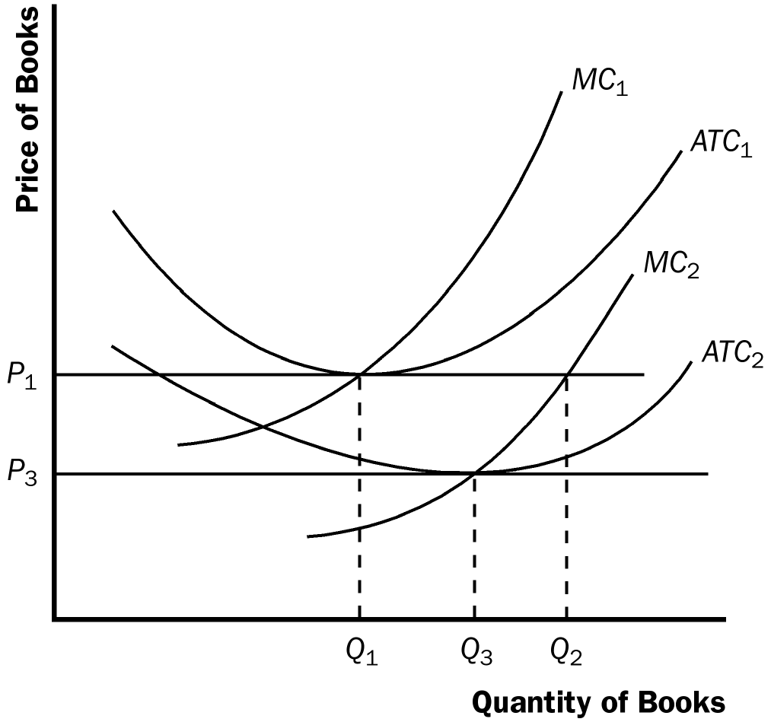

Figure 7

10. The rise in the price of petroleum increases production costs for individual firms and thus shifts the industry supply curve up, as shown in Figure 8. The typical firm's initial marginal-cost curve is MC₁ and its average-total-cost curve is ATC₁. In the initial equilibrium, the industry supply curve, S₁, intersects the demand curve at price P₁, which is equal to the minimum average total cost of the typical firm. Thus the typical firm earns no economic profit.

The increase in the price of oil shifts the typical firm's cost curves up to MC₂ and ATC₂, and shifts the industry supply curve up to S₂. The equilibrium price rises from P₁ to P₂, but the price does not increase by as much as the increase in marginal cost for the firm. As a result, price is less than average total cost for the firm, so profits are negative.

In the long run, the negative profits lead some firms to exit the industry. As they do so, the industry-supply curve shifts to the left. This continues until the price rises to equal the minimum point on the firm's average-total-cost curve. The long-run equilibrium occurs with supply curve S₃, equilibrium price P₃, industry output Q₃, and firm's output q₃. Thus, in the long run, profits are zero again and there are fewer firms in the industry.

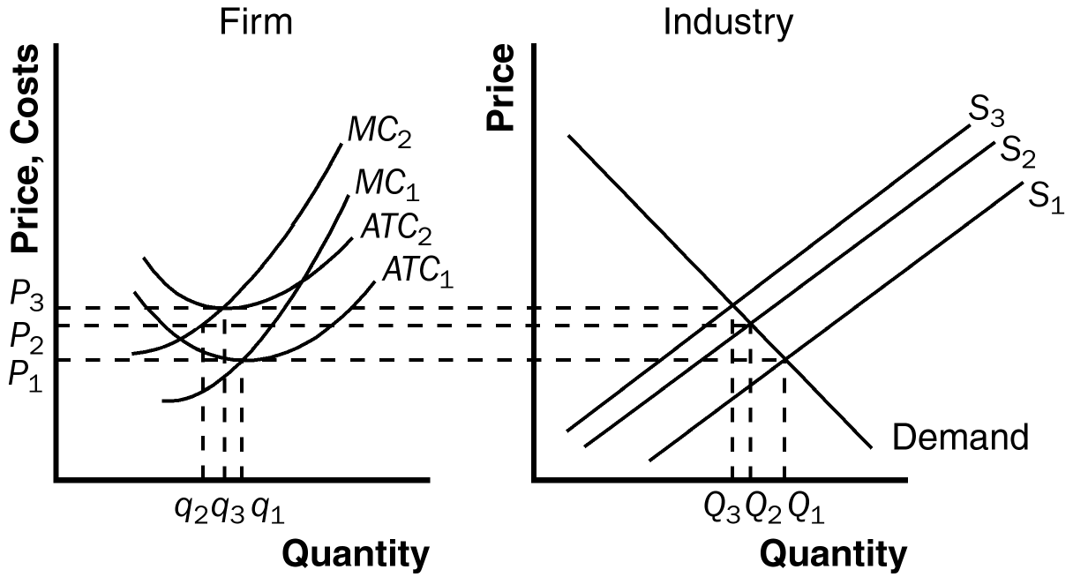

Figure 8

11. a. Figure 9 illustrates the situation in the U.S. textile industry. With no international trade, the market is in long-run equilibrium. Supply intersects demand at quantity Q₁ and price $30, with a typical firm producing output q₁.

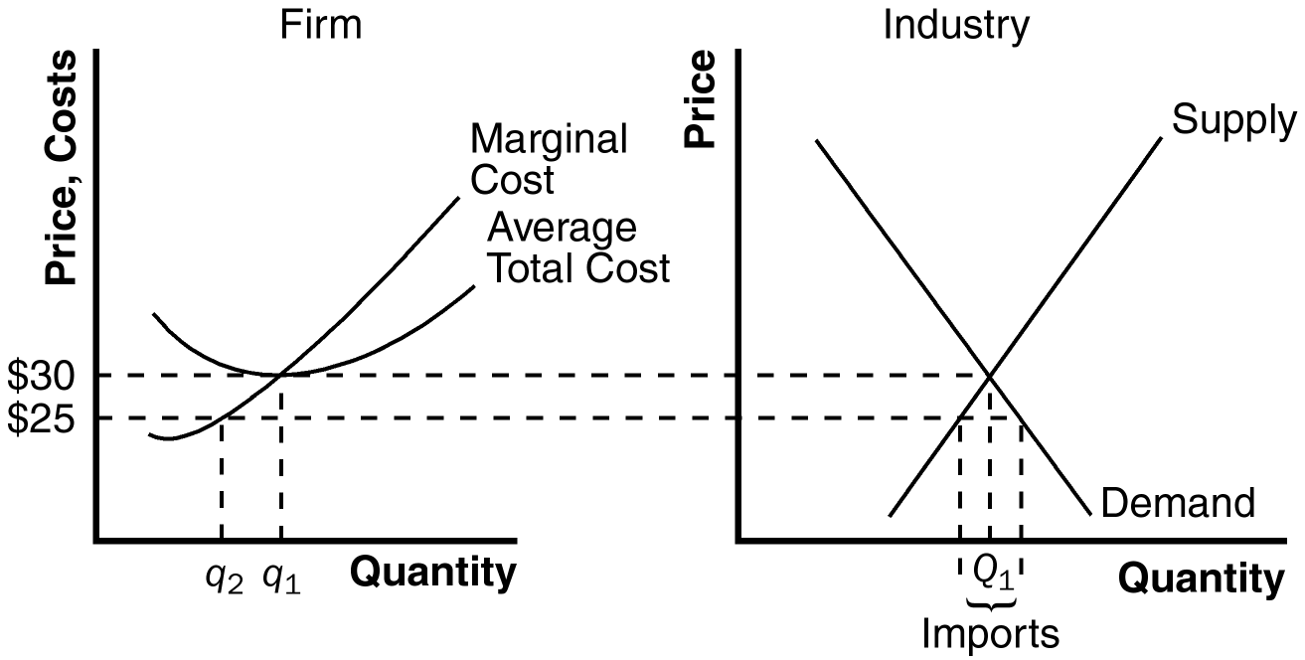

Figure 9

b. The effect of imports at $25 is that the market supply curve follows the old supply curve up to a price of $25, then becomes horizontal at that price. As a result, demand exceeds domestic supply, so the country imports textiles from other countries. The typical domestic firm now reduces its output from q₁ to q₂, incurring losses, since the large fixed costs imply that average total cost will be much higher than the price.

c. In the long run, domestic firms will be unable to compete with foreign firms because their costs are too high. All the domestic firms will exit the industry and other countries will supply enough to satisfy the entire domestic demand.

12. a. Figure 10 shows the current equilibrium in the market for pretzels. The supply curve, S₁, intersects the demand curve at price P₁. Each stand produces quantity q₁ of pretzels, so the total number of pretzels produced is 1,000 x q₁. Stands earn zero profit, since price equals average total cost.

b. If the city government restricts the number of pretzel stands to 800, the industry-supply curve shifts to S₂. The market price rises to P₂, and individual firms produce output q₂. Industry output is now 800 x q₂. Now the price exceeds average total cost, so each firm is making a positive profit. Without restrictions on the market, this would induce other firms to enter the market, but they cannot, since the government has limited the number of licenses.

c. The city could charge a license fee for the licenses. Since it is a lump-sum fee for the license, not based on the quantity of sales, such a tax has no effect on marginal cost, so won't affect the firm's output. It will, however, reduce the firm's profits. As long as the firm is left with a zero or positive profit, it will continue to operate. So the license fee that brings the most money to the city is to charge each firm the amount (P₂ - ATC₂)q₂, the amount of the firm's profit.

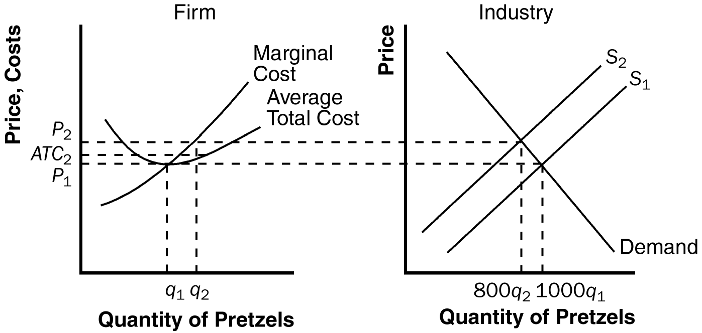

Figure 10

13. a. Figure 11 illustrates the gold market (industry) and a representative gold mine (firm). The demand curve, D₁, intersects the supply curve at industry quantity Q₁ and price P₁. Since the industry is in long-run equilibrium, the price equals the minimum point on the representative firm's average total cost curve, so the firm produces output q₁ and makes zero profit.

b. The increase in jewelry demand leads to an increase in the demand for gold, shifting the demand curve to D₂. In the short run, the price rises to P₂, industry output rises to Q₂, and the representative firm's output rises to q₂. Since price now exceeds average total cost, the representative firm now earns positive profits.

c. Since gold mines are earning positive economic profits, over time other firms will enter the industry. This will shift the supply curve to the right, reducing the price below P₂. But it's unlikely that the price will fall all the way back to P₁, since gold is in short supply. Costs for new firms are likely to be higher than for older firms, since they'll have to discover new gold sources. So it's likely that the long-run supply curve in the gold industry is upward sloping. That means the long-run equilibrium price will be higher than it was initially.

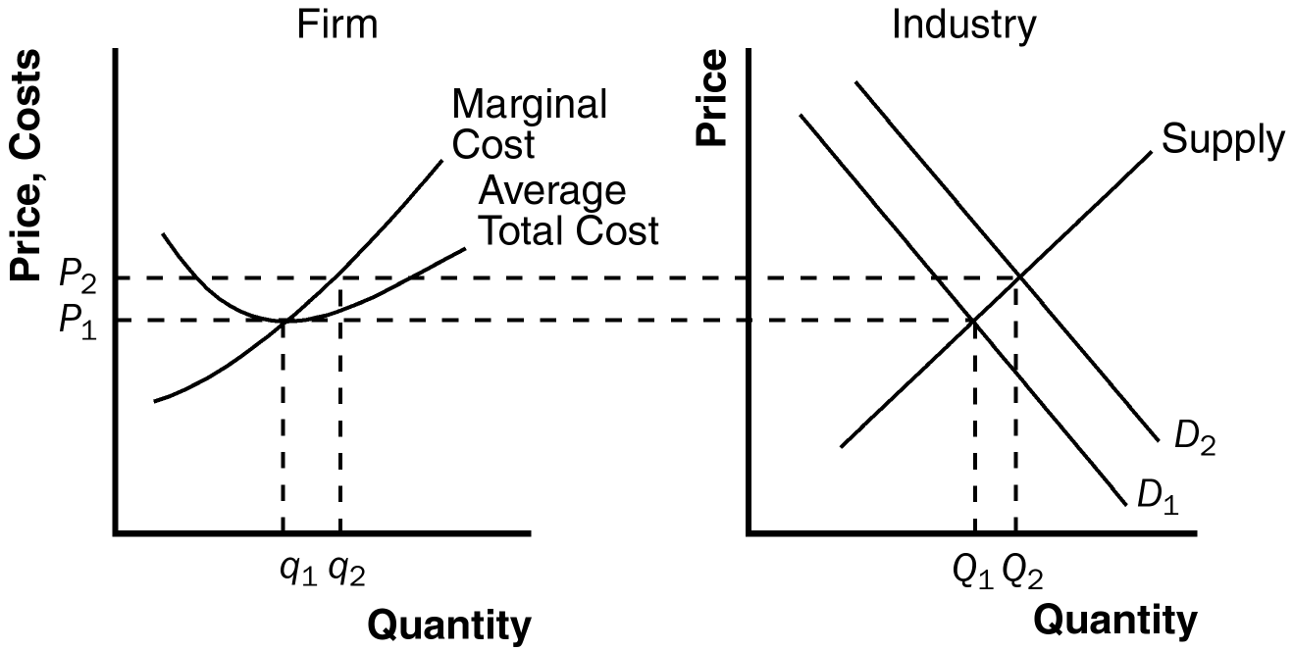

Figure 11

14. a. Figure 12 shows cost curves for a California refiner and a non-California refiner. Since the California refiner has access to lower-cost oil, its costs are lower.

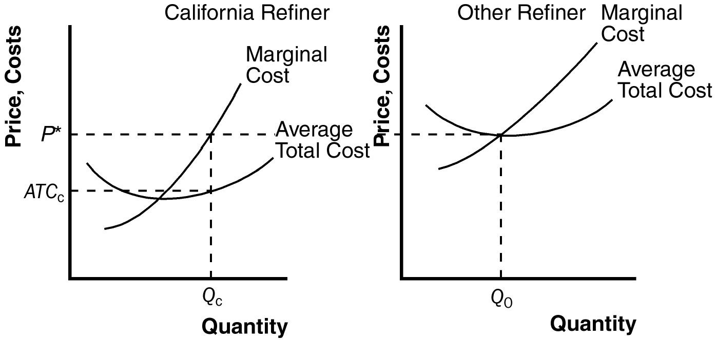

Figure 12

b. In long-run equilibrium, the price is determined by the costs of non-California refiners, since California refiners cannot supply the entire market. The market price will equal the minimum average total cost of the other refiners; they will thus earn zero profits. Since California refiners have lower costs, they will earn positive profits, equal to (P* - ATC_{C}) x Q_{C}.

c. Yes, there is a subsidy to California refiners that is not passed on to consumers. The subsidy accounts for the long-run profits of the California refiners. It arises simply because the oil cannot be exported.

Chapter 15: SOLUTIONS TO TEXT PROBLEMS:

Quick Quizzes

1. A market might have a monopoly because: (1) a key resource is owned by a single firm; (2) the government gives a single firm the exclusive right to produce some good; and (3) the costs of production make a single producer more efficient than a large number of producers.

Examples of monopolies include: (1) the water producer in a small town, which owns a key resource, the one well in town; (2) pharmaceutical companies who are given a patent on a new drug by the government; and (3) a bridge, which is a natural monopoly because (if the bridge is uncongested) having just one bridge is efficient. Many other examples are possible.

2. A monopolist chooses the amount of output to produce by finding the quantity at which marginal revenue equals marginal cost. It finds the price to charge by finding the point on the demand curve at that quantity.

3. A monopolist produces a quantity of output that’s less than the quantity of output that maximizes total surplus because it produces the quantity at which marginal cost equals marginal revenue rather than the quantity at which marginal cost equals price.

4. Policymakers can respond to the inefficiencies caused by monopolies in one of four ways: (1) by trying to make monopolized industries more competitive; (2) by regulating the behavior of the monopolies; (3) by turning some private monopolies into public enterprises; and (4) by doing nothing at all. Antitrust laws prohibit mergers of large companies and prevent them from coordinating their activities in ways that make markets less competitive, but such laws may keep companies from merging to gain from synergies. Some monopolies, especially natural monopolies, are regulated by the government, but it is hard to keep a monopoly in business, achieve marginal-cost pricing, and give the monopolist incentive to reduce costs. Private monopolies can be taken over by the government, but the companies are not likely to be well run. Sometimes doing nothing at all may seem to be the best solution, but there are clearly deadweight losses from monopoly that society will have to bear.

5. Examples of price discrimination include: (1) movie tickets, for which children and senior citizens get lower prices; (2) airline prices, which are different for business and leisure travelers; (3) discount coupons, which lead to different prices for people who value their time in different ways; (4) financial aid, which offers college tuition at lower prices to poor students and higher prices to wealthy students; and (5) quantity discounts, which offer lower prices for higher quantities, capturing more of a buyer’s willingness to pay. Many other examples are possible.

Perfect price discrimination reduces consumer surplus, increases producer surplus by the same amount, and has no effect on total surplus, compared to a competitive market. Compared to a monopoly that charges a single price, perfect price discrimination reduces consumer surplus, increases producer surplus, and increases total surplus, since there is no deadweight loss.

Questions for Review

1. An example of a government-created monopoly comes from the existence of patent and copyright laws. Both allow firms or individuals to be monopolies for extended periods of time—20 years for patents, forever for copyrights. But this monopoly power is good, because without it, no one would write a book (because anyone could print copies of it, so the author would get no income) and no firm would invest in research and development to invent new products or drugs (since any other company could produce or sell them, and the firm would get no profit from its investment).

2. An industry is a natural monopoly when a single firm can supply a good or service to an entire market at a smaller cost than could two or more firms. As a market grows it may evolve from a natural monopoly to a competitive market.

3. A monopolist's marginal revenue is less than the price of its product because: (1) its demand curve is the market demand curve, so (2) to increase the amount sold, the monopolist must lower the price of its good for every unit it sells. (3) This cut in prices reduces revenue on the units it was already selling.

A monopolist's marginal revenue can be negative because to get purchasers to buy an additional unit of the good, the firm must reduce its price on all units of the good. The fact that it sells a greater quantity increases revenue, but the decline in price decreases revenue. The overall effect depends on the elasticity of the demand curve. If the demand curve is inelastic, marginal revenue will be negative.

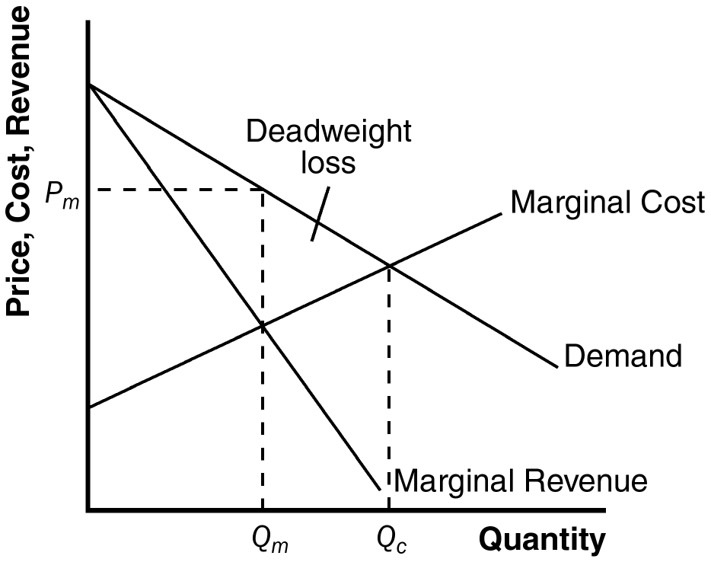
4. Figure 1 shows the demand, marginal-revenue, and marginal-cost curves for a monopolist. The intersection of the marginal-revenue and marginal-cost curves determines the profit-maximizing level of output, Q_{m}. The demand curve then shows the profit-maximizing price, P_{m}.

Figure 1

5. The level of output that maximizes total surplus in Figure 1 is where the demand curve intersects the marginal-cost curve, Q_{c}. The deadweight loss from monopoly is the triangular area between Q_{c} and Q_{m} that is above the marginal-cost curve and below the demand curve. It represents deadweight loss, since society loses total surplus because of monopoly, equal to the value of the good (measured by the height of the demand curve) less the cost of production (given by the height of the marginal-cost curve), for the quantities between Q_{m} and Q_{c}.

6. The government has the power to regulate mergers between firms because of antitrust laws. Firms might want to merge to increase operating efficiency and reduce costs, something that is good for society, or to gain monopoly power, which is bad for society.

7. When regulators tell a natural monopoly that it must set price equal to marginal cost, two problems arise. The first is that, because a natural monopoly has a constant marginal cost that is less than average cost, setting price equal to marginal cost means that the price is less than average cost, so the firm will lose money. The firm would then exit the industry unless the government subsidized it. However, getting revenue for such a subsidy would cause the government to raise other taxes, increasing the deadweight loss. The second problem of using costs to set price is that it gives the monopoly no incentive to reduce costs.

8. One example of price discrimination is in publishing books. Publishers charge a much higher price for hardback books than for paperback books—far higher than the difference in production costs. Publishers do this because die-hard fans will pay more for a hardback book when the book is first released. Those who don't value the book as highly will wait for the paperback version to come out. The publisher makes greater profit this way than if it charged just one price.

A second example is the pricing of movie tickets. Theaters give discounts to children and senior citizens because they have a lower willingness to pay for a ticket. Charging different prices helps the theater increase its profit above what it would be if it charged just one price.

Problems and Applications

1. The following table shows revenue, costs, and profits, where quantities are in thousands, and total revenue, total cost, and profit are in millions of dollars:

Price | Quantity  (1,000s) | Total Revenue | Marginal Revenue | Total Cost | Profit
$ 100 | 0 | $ 0 | ---- | $ 2 | $ -2
90 | 100 | 9 | $ 9 | 3 | 6
80 | 200 | 16 | 7 | 4 | 12
70 | 300 | 21 | 5 | 5 | 16
60 | 400 | 24 | 3 | 6 | 18
50 | 500 | 25 | 1 | 7 | 18
40 | 600 | 24 | -1 | 8 | 16
30 | 700 | 21 | -3 | 9 | 12
20 | 800 | 16 | -5 | 10 | 6
10 | 900 | 9 | -7 | 11 | -2
0 | 1,000 | 0 | -9 | 12 | -12

a. A profit-maximizing publisher would choose a quantity of 400,000 at a price of $60 or a quantity of 500,000 at a price of $50; both combinations would lead to profits of $18 million.

b. Marginal revenue is always less than price. Price falls when quantity rises because the demand curve slopes downward, but marginal revenue falls even more than price because the firm loses revenue on all the units of the good sold when it lowers the price.

c. Figure 2 shows the marginal-revenue, marginal-cost, and demand curves. The marginal-revenue and marginal-cost curves cross between quantities of 400,000 and 500,000. This signifies that the firm maximizes profits in that region.

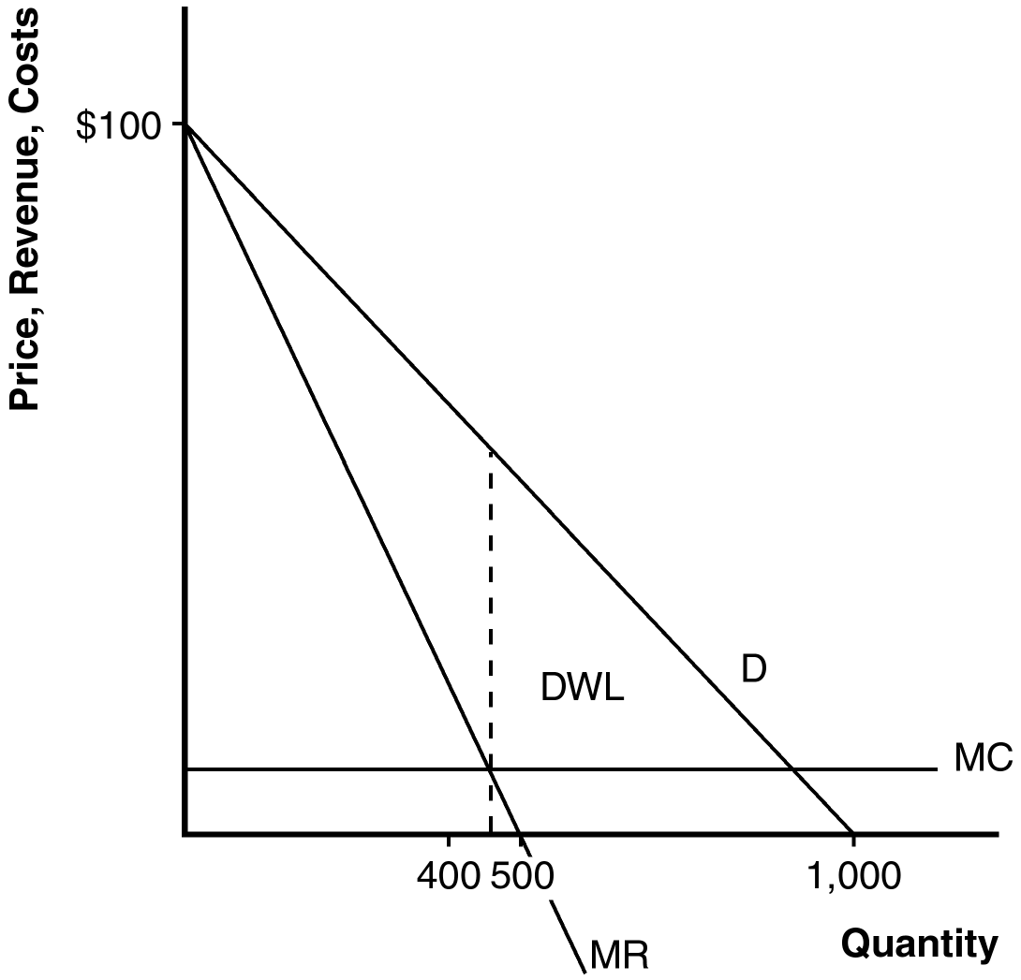

Figure 2

d. The area of deadweight loss is marked “DWL” in the figure. Deadweight loss means that the total surplus in the economy is less than it would be if the market were competitive, since the monopolist produces less than the socially efficient level of output.

e. If the author were paid $3 million instead of $2 million, the publisher wouldn’t change the price, since there would be no change in marginal cost or marginal revenue. The only thing that would be affected would be the firm’s profit, which would fall.

f. To maximize economic efficiency, the publisher would set the price at $10 per book, since that’s the marginal cost of the book. At that price, the publisher would have negative profits equal to the amount paid to the author.

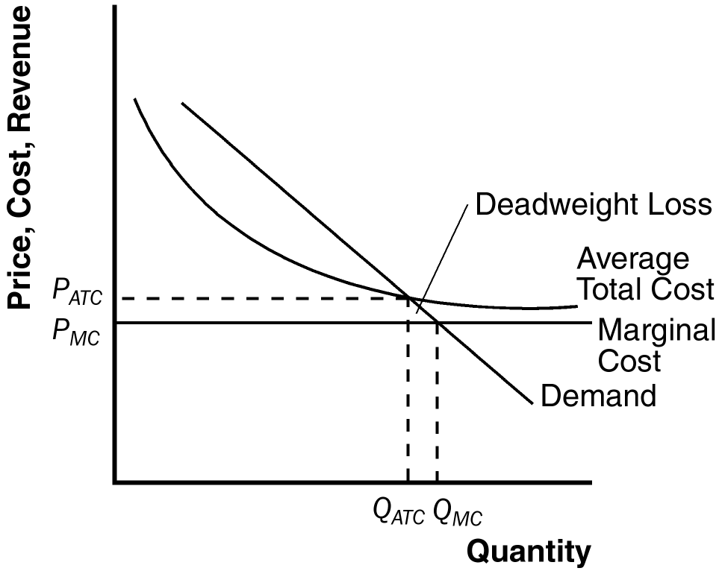

Figure 3

2. Figure 3 illustrates a natural monopolist setting price, P_{ATC}, equal to average total cost. The equilibrium quantity is Q_{ATC}. Marginal cost pricing would yield the price P_{MC} and quantity Q_{MC}. For quantities between Q_{ATC} and Q_{MC}, the benefit to consumers (measured by the demand curve) exceeds the cost of production (measured by the marginal cost curve). This means that the deadweight loss from setting price equal to average total cost is the triangular area shown in the figure.

3. Mail delivery has an always-declining average-total-cost curve, since there are large fixed costs for equipment. The marginal cost of delivering a letter is very small. However, the costs are higher in isolated rural areas than they are in densely populated urban areas, since transportation costs differ. Over time, increased automation has reduced marginal cost and increased fixed costs, so the average-total-cost curve has become steeper at small quantities and flatter at high quantities.

4. If the price of tap water rises, the demand for bottled water increases. This is shown in Figure 4 as a shift to the right in the demand curve from D₁ to D₂. The corresponding marginal-revenue curves are MR₁ and MR₂. The profit-maximizing level of output is where marginal cost equals marginal revenue. Prior to the increase in the price of tap water, the profit-maximizing level of output is Q₁; after the price increase, it rises to Q₂. The profit-maximizing price is shown on the demand curve: it is P₁ before the price of tap water rises, and it rises to P₂ after. Average cost is AC₁ before the price of tap water rises and AC₂ after. Profit increases from (P₁ - AC₁) x Q₁ to (P₂ - AC₂) x Q₂.

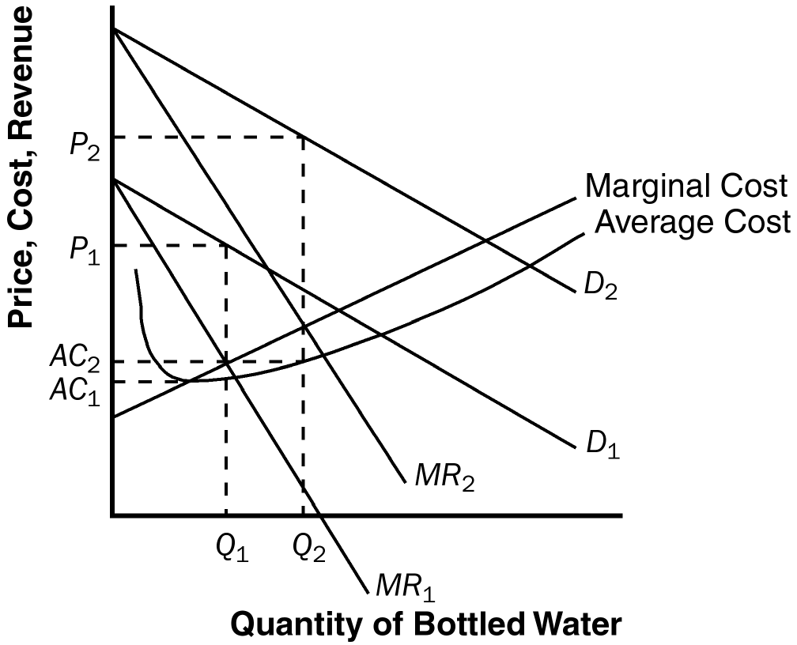

Figure 4

5. a. Figure 5 illustrates the market for groceries when there are many competing supermarkets with constant marginal cost. Output is Q_{C}, price is P_{C}, consumer surplus is area A, producer surplus is zero, and total surplus is area A.

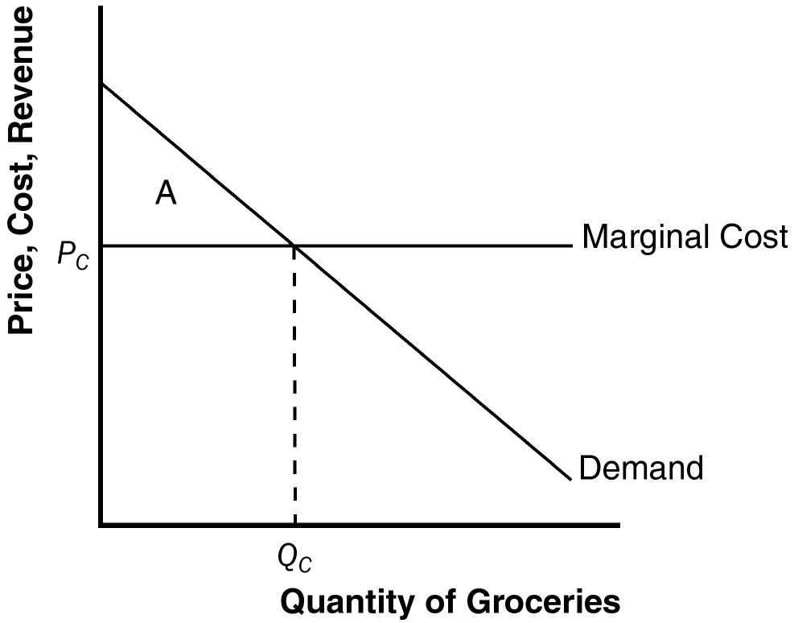

Figure 5

b. If the supermarkets merge, Figure 6 illustrates the new situation. Quantity declines from Q_{C} to Q_{M} and price rises to P_{M}. Area A in Figure 5 is equal to area B + C + D + E + F in Figure 6. Consumer surplus is now area B + C, producer surplus is area D + E, and total surplus is area B + C + D + E. Consumers transfer the amount of area D + E to producers and the deadweight loss is area F.

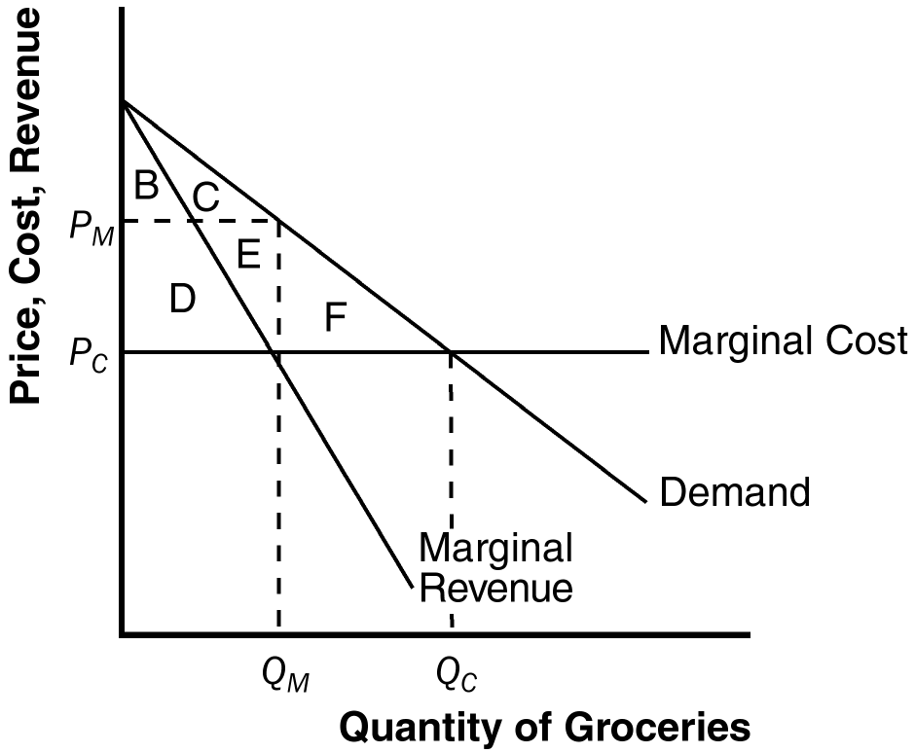

Figure 6

6. a. The following table shows total revenue and marginal revenue for each price and quantity sold:

Price | Quantity | Total Revenue | Marginal Revenue | Total Cost | Profit
24 | 10,000 | $ 240,000 | ---- | $ 50,000 | $ 190,000
22 | 20,000 | 440,000 | $ 20 | 100,000 | 340,000
20 | 30,000 | 600,000 | 16 | 150,000 | 450,000
18 | 40,000 | 720,000 | 12 | 200,000 | 520,000
16 | 50,000 | 800,000 | 8 | 250,000 | 550,000
14 | 60,000 | 840,000 | 4 | 300,000 | 540,000

b. Profits are maximized at a price of $16 and quantity of 50,000. At that point, profit is $550,000.

c. As Johnny's agent, you should recommend that he demand $550,000 from them, so he instead of the record company receives all of the profit.

7. IBM's monopoly power will be constrained to the extent that people can substitute other computers for mainframes. So the government might have looked at the demand curve facing IBM, or the divergence between IBM's price and marginal cost, to get some idea of how severe the monopoly problem was.

8. a. The table below shows total revenue and marginal revenue for the bridge. The profit-maximizing price would be where revenue is maximized, which will occur where marginal revenue equals zero, since marginal cost equals zero. This occurs at a price of $4 and quantity of 400. The efficient level of output is 800, since that's where price equals marginal cost equals zero. The profit-maximizing quantity is lower than the efficient quantity because the firm is a monopolist.

Price | Quantity | Total Revenue | Marginal Revenue
$ 8 | 0 | $ 0 | ----
7 | 100 | 700 | $ 7
6 | 200 | 1,200 | 5
5 | 300 | 1,500 | 3
4 | 400 | 1,600 | 1
3 | 500 | 1,500 | -1
2 | 600 | 1,200 | -3
1 | 700 | 700 | -5
0 | 800 | 0 | -7

b. The company should not build the bridge because its profits are negative. The most revenue it can earn is $1,600,000 and the cost is $2,000,000, so it would lose $400,000.

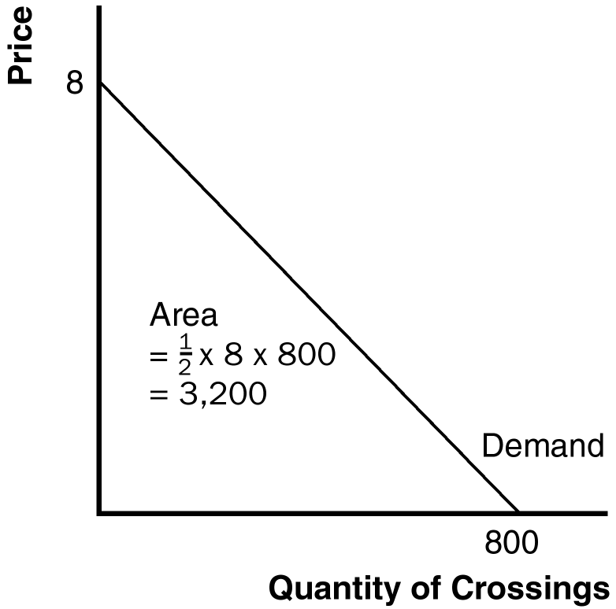

Figure 7

c. If the government were to build the bridge, it should set price equal to marginal cost to be efficient. But marginal cost is zero, so the government should not charge people to use the bridge.

d. Yes, the government should build the bridge, because it would increase society's total surplus. As shown in Figure 7, total surplus has area 1/2 x 8 x 800,000 = $3,200,000, which exceeds the cost of building the bridge.

9. a. Figure 8 illustrates the drug company's situation. They will produce quantity Q₁ at price P₁. Profits are equal to (P₁ - AC₁) x Q₁.

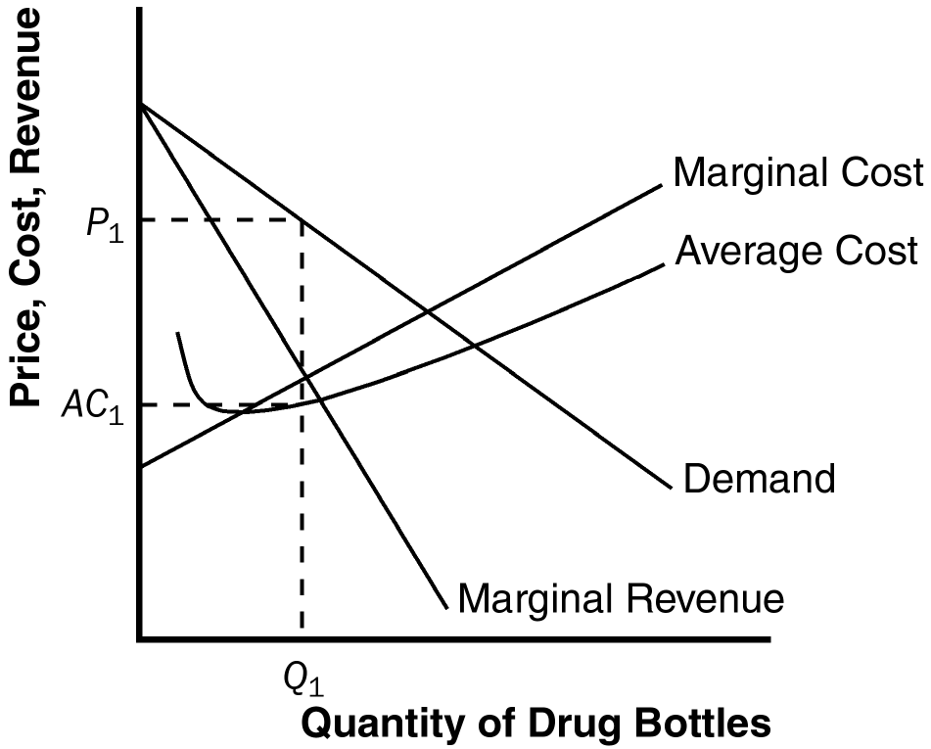

Figure 8

b. The tax on the drug increases both marginal cost and average cost by the amount of the tax. As a result, as shown in Figure 9, quantity is reduced to Q₂, price rises to P₂, and average cost plus tax rises to AC₂.

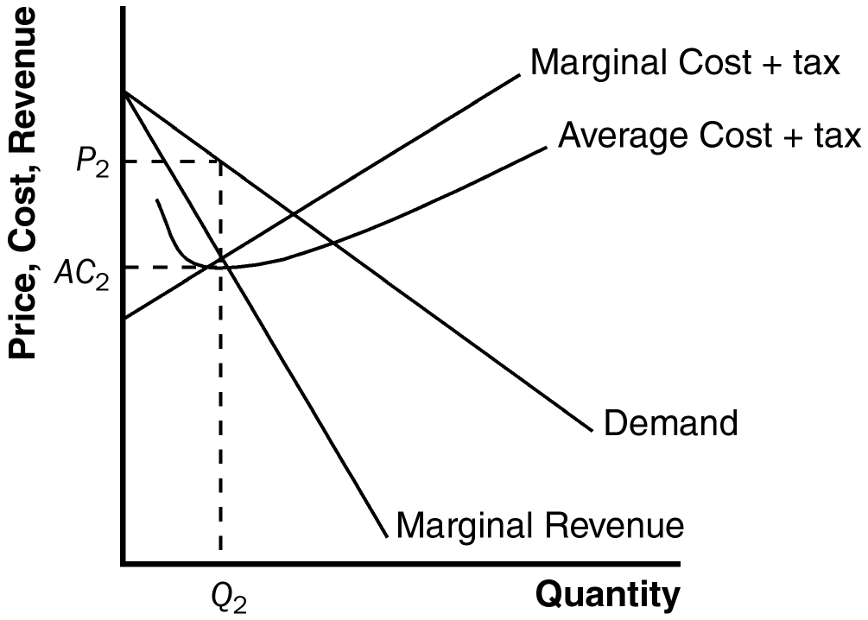

Figure 9

c. The tax definitely reduces profits. After all, the firm could have produced quantity Q₂ at price P₂ before the tax was imposed, but it chose not to because this level did not maximize profit before the tax occurred.

d. A tax of $10,000 regardless of how many bottles of the drug are produced would result in the quantity produced at Q₁ and the price at P₁ in Figure 8 because such a tax does not affect marginal cost or marginal revenue. It does, however, raise average cost; in fact, profits decline by exactly $10,000.

10. Larry wants to sell as many drinks as possible without losing money, so he wants to set quantity where price (demand) equals average cost, which occurs at quantity Q_{L} and price P_{L} in Figure 10. Curly wants to bring in as much revenue as possible, which occurs where marginal revenue equals zero, at quantity Q_{C} and price P_{C}. Moe wants to maximize profits, which occurs where marginal cost equals marginal revenue, at quantity Q_{M} and price P_{M}.

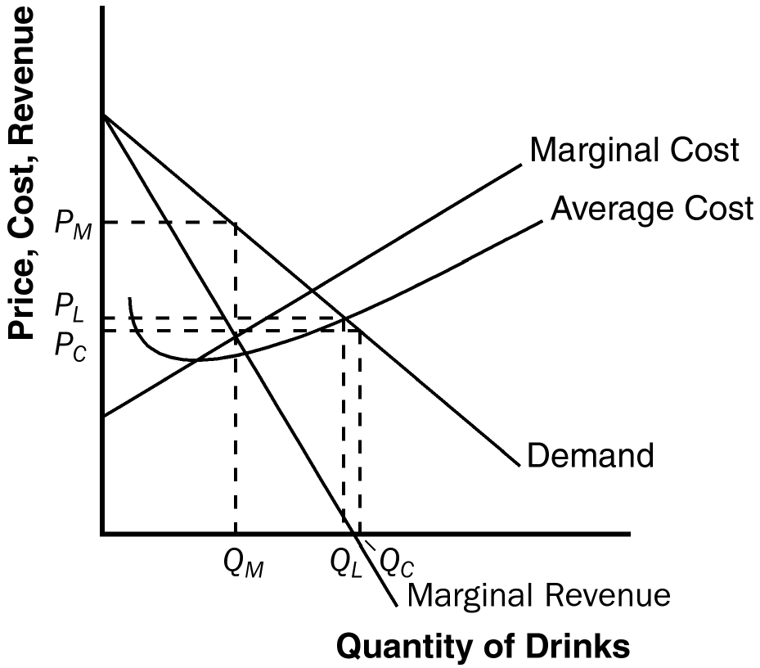

Figure 10

11. a. Long-distance phone service was originally a natural monopoly because installation of phone lines across the country meant that one firm's costs were much lower than if two or more firms did the same thing.

b. With communications satellites, the cost is no different if one firm supplies them or if many firms do so. So the industry evolved from a natural monopoly to a competitive market.

c. It is efficient to have competition in long-distance phone service and regulated monopolies in local phone service because local phone service remains a natural monopoly (being based on land lines) while long-distance service is a competitive market (being based on satellites).

12. a. The patent gives the company a monopoly, as shown in Figure 11. At a quantity of Q_{M} and price of P_{M}, consumer surplus is area A + B, producer surplus is area C + D, and total surplus is area A + B + C + D.

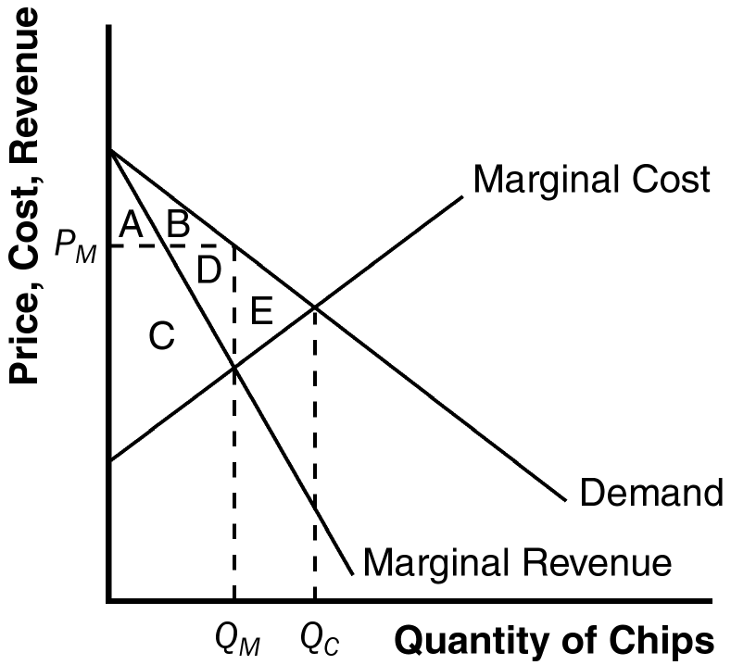

Figure 11

b. If the firm can perfectly price discriminate, it will produce quantity Q_{C} and extract all the consumer surplus. Consumer surplus is zero and producer surplus is A + B + C + D + E, as is total surplus. Deadweight loss is reduced from area E to zero. There is a transfer of surplus from consumers to producers of area A + B.

13. A monopolist always produces a quantity at which the demand curve is elastic. If the firm produced a quantity for which the demand curve were inelastic, then if the firm raised its price, quantity would fall by a smaller percentage than the rise in price, so revenue would increase. Since costs would decrease at a lower quantity, the firm would have higher revenue and lower costs, so profit would be higher. Thus the firm should keep raising its price until profits are maximized, which must happen on an elastic portion of the demand curve.

Another way to see this is to note that on an inelastic portion of the demand curve, marginal revenue is negative. Increasing quantity requires a greater percentage reduction in price, so revenue declines. Since a firm maximizes profit where marginal cost equals marginal revenue, and marginal cost is never negative, the profit-maximizing quantity can never occur where marginal revenue is negative, so can never be on an inelastic portion of the demand curve.

14. Though Britney Spears has a monopoly on her own singing, there are many other singers in the market. If Spears were to raise her price too much, people would substitute to other singers. So there is no need for the government to regulate the price of her concerts.

15. Because the marginal cost of the music was virtually zero, Napster enhanced economic efficiency because those individuals who valued the music more than zero but less than the selling price were able to consume it. However, in the long run, musicians and record companies would have no incentive to release new music because everyone could own a copy of it without paying for it. The courts eventually shut Napster down because they believed that this access violated copyright laws.

16. a. Figure 12 shows the cost, demand, and marginal-revenue curves for the monopolist. Without price discrimination, the monopolist would charge price P_{M} and produce quantity Q_{M}.

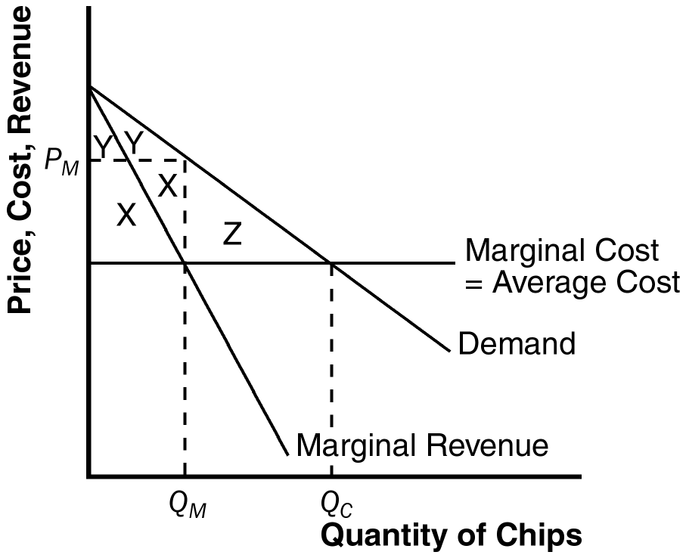

Figure 15-12

b. The monopolist's profit consists of the two areas labeled X, consumer surplus is the two areas labeled Y, and the deadweight loss is the area labeled Z.

c. If the monopolist can perfectly price discriminate, it produces quantity Q_{C}, and has profit equal to X + Y + Z.

d. The monopolist's profit increases from X to X + Y + Z, an increase in the amount Y + Z. The change in total surplus is area Z. The rise in monopolist's profit is greater than the change in total surplus, since monopolist's profit increases both by the amount of deadweight loss (Z) and by the transfer from consumers to the monopolist (Y).

e. A monopolist would pay the fixed cost that allows it to discriminate as long as Y + Z (the increase in profits) exceeds C (the fixed cost).

f. A benevolent social planner who cared about maximizing total surplus would want the monopolist to price discriminate only if Z (the deadweight loss from monopoly) exceeded C (the fixed cost) since total surplus rises by Z - C.

g. The monopolist has a greater incentive to price discriminate (it will do so if Y + Z > C) than the social planner would allow (she would allow it only if Z > C). Thus if Z < C but Y + Z > C, the monopolist will price discriminate even though it is not in society's best interest.

Chapter 16: SOLUTIONS TO TEXT PROBLEMS:

Quick Quizzes

1. Oligopoly is a market structure in which only a few sellers offer similar or identical products. Examples include the market for tennis balls and the world market for crude oil. Monopolistic competition is a market structure in which many firms sell products that are similar but not identical. Examples include the markets for novels, movies, CDs, and computer games.

2. If the members of an oligopoly could agree on a total quantity to produce, they would choose to produce the monopoly quantity, acting in collusion as if they were a monopoly.

If the members of the oligopoly make production decisions individually, they produce a greater quantity than the monopoly quantity because self-interest leads them to produce more than the monopoly quantity.

3. The prisoners’ dilemma is the story of two criminals suspected of committing a crime, in which the sentence that each receives depends both on his or her decision whether to confess or remain silent and on the decision made by the other. The following table shows the prisoners’ choices:

 |  | Bonnie's Decision
 |  | Confess | Remain Silent
Clyde's  Decision | Confess | Bonnie gets 8 years Clyde gets 8 years | Bonnie gets 20 years  Clyde goes free
Clyde's  Decision | Remain Silent | Bonnie goes free  Clyde gets 20 years | Bonnie gets 1 year Clyde gets 1 year

The likely outcome is that both will confess, since that’s a dominant strategy for both.

The prisoners’ dilemma teaches us that oligopolies have trouble maintaining monopoly profits because each oligopolist has an incentive to cheat.

4. It is illegal for businesses to make an agreement about reducing quantities or raising prices.

Antitrust laws are controversial because it isn’t always clear which kinds of behavior these laws should prohibit, such as resale price maintenance, predatory pricing, and tying.

Questions for Review

1. If a group of sellers could form a cartel, they would try to set quantity and price like a monopolist. They would set quantity at the point where marginal revenue equals marginal cost, and set price at the corresponding point on the demand curve.

2. Firms in an oligopoly produce a quantity of output greater than the level produced by monopoly at a price lower than the monopoly price.

3. Firms in an oligopoly produce a quantity of output less than the level produced by a perfectly competitive market at a price greater than the perfectly competitive price.

4. As the number of sellers in an oligopoly grows larger, an oligopolistic market looks more and more like a competitive market. The price approaches marginal cost, and the quantity produced approaches the socially efficient level.

5. The prisoners' dilemma is a game between two people or firms that illustrates why it is difficult for opponents to cooperate even when cooperation would make them all better off. Each person or firm has a great incentive to cheat on any cooperative agreement to make himself or itself better off.

6. The arms race, advertising, and common resources are some examples of how the prisoners' dilemma helps explain behavior. In the arms race during the Cold War, the United States and the Soviet Union couldn't agree on arms reductions because each was fearful that after cooperating for a while, the other country would cheat. In advertising, two companies would be better off if neither advertised, but each is fearful that if it doesn't advertise, the other company will. When two companies share a common resource, they would be better off sharing it. But fearful that the other company will use more of the common resource, each company ends up overusing it.

7. Antitrust laws prohibit firms from trying to monopolize a market. They are used to prevent mergers that would lead to excessive market power in any firm and to keep oligopolists from acting together in ways that would make the market less competitive.

8. Resale price maintenance occurs when a wholesaler sets a minimum price that retailers can charge. This might seem to be anticompetitive because it prevents retailers from competing on price. But that is doubtful because: (1) if the wholesaler has market power, it can exercise such power through the wholesale price; (2) wholesalers have no incentive to discourage competition among retailers since doing so reduces the quantity sold; and (3) maintaining a minimum price may be valuable so retailers will provide customers with good service.

Problems and Applications

1. a. OPEC members were trying to reach an agreement to cut production so they could raise the price.

b. They were unable to agree on cutting production because each country has an incentive to cheat on any agreement. The turmoil is a decline in the price of oil because of increased production.

c. OPEC would like Norway and Britain to join their cartel so they could act like a monopoly.

2. a. If there were many suppliers of diamonds, price would equal marginal cost ($1,000), so the quantity would be 12,000.

b. With only one supplier of diamonds, quantity would be set where marginal cost equals marginal revenue. The following table derives marginal revenue:

Price  (thousands of dollars) | Quantity  (thousands) | Total Revenue  (millions of dollars) | Marginal Revenue  (millions of dollars)
8 | 5 | 40 | ----
7 | 6 | 42 | 2
6 | 7 | 42 | 0
5 | 8 | 40 | –2
4 | 9 | 36 | –4
3 | 10 | 30 | –6
2 | 11 | 22 | –8
1 | 12 | 12 | –10

With marginal cost of $1,000 per diamond, or $1 million per thousand diamonds, the monopoly will maximize profits at a price of $7,000 and a quantity of 6,000. Additional production beyond this point would lead to a situation where marginal revenue is lower than marginal cost.

c. If Russia and South Africa formed a cartel, they would set price and quantity like a monopolist, so the price would be $7,000 and the quantity would be 6,000. If they split the market evenly, they would share total revenue of $42 million and costs of $6 million, for a total profit of $36 million. So each would produce 3,000 diamonds and get a profit of $18 million. If Russia produced 3,000 diamonds and South Africa produced 4,000, the price would decline to $6,000. South Africa's revenue would rise to $24 million, costs would be $4 million, so profits would be $20 million, which is an increase of $2 million.

d. Cartel agreements are often not successful because one party has a strong incentive to cheat to make more profit. In this case, each could increase profit by $2 million by producing an extra thousand diamonds. However, if both countries did this, profits would decline for both of them.

3. a. Buyers who are oligopolists try to decrease the prices of goods they buy.

b. The owners of baseball teams would like to keep players' salaries low. This goal is difficult to achieve because each team has an incentive to cheat on any agreement, since they will be able to attract better players by offering higher salaries.

c. The salary cap would have formalized the collusion on salaries and helped to prevent any team from cheating.

4. Many answers are possible, such as picking which movie to see with your friend or negotiating the price of a car. The common link among all the activities is that there are just a few people involved who act strategically.

5. a. If Mexico imposes low tariffs, then the United States is better off with high tariffs, since it gets $30 billion with high tariffs and only $25 billion with low tariffs. If Mexico imposes high tariffs, then the United States is better off with high tariffs, since it gets $20 billion with high tariffs and only $10 billion with low tariffs. So the United States has a dominant strategy of high tariffs.

If the United States imposes low tariffs, then Mexico is better off with high tariffs, since it gets $30 billion with high tariffs and only $25 billion with low tariffs. If the United States imposes high tariffs, then Mexico is better off with high tariffs, since it gets $20 billion with high tariffs and only $10 billion with low tariffs. So Mexico has a dominant strategy of high tariffs.

b. A Nash equilibrium is a situation in which economic actors interacting with one another each choose their best strategy given the strategies others have chosen. The Nash equilibrium in this case is for each country to have high tariffs.

c. The NAFTA agreement represents cooperation between the two countries. Each country reduces tariffs and both are better off as a result.

d. The payoffs in the upper left and lower right parts of the box do reflect a nation's welfare. Trade is beneficial and tariffs are a barrier to trade. However, the payoffs in the upper right and lower left parts of the box are not valid. A tariff hurts domestic consumers and helps domestic producers, but total surplus declines, as we saw in Chapter 9. So it would be more accurate for these two areas of the box to show that both countries' welfare will decline if they imposed high tariffs, whether or not the other country had high or low tariffs.

6. a. Dropping the letter grade by two letters (e.g., A to C) if you have no fun gives the payoffs shown in this table:

 |  | Your Decision
 |  | Work | Shirk
Classmate's  Decision | Work | You get a C  Classmate gets a C | You get a B  Classmate gets a D
Classmate's  Decision | Shirk | You get a D  Classmate gets a B | You get a D  Classmate gets a D

b. The likely outcome is that both of you will shirk. If your classmate works, you're better off shirking, because you would rather have an overall B (a B grade and fun) then an overall C (an A grade and no fun). If your classmate shirks, you are indifferent between working for an overall D (a B grade with no fun) and shirking for an overall D (a D grade and fun). So your dominant strategy is to shirk. Your classmate faces the same payoffs, so will also shirk. But if you are likely to work with the same person again, you have a greater incentive to work, so that your classmate will work, so you will both be better off. In repeated games, cooperation is more likely.

7. Even though the ban on cigarette advertising increased the profits of cigarette companies, it was good public policy because it reduced the quantity of cigarette consumption. Since cigarette consumption imposes an externality because of its health costs, the reduction in quantity is beneficial.

8. a. The decision box for this game is:

 |  | Braniff's Decision
 |  | Low Price | High Price
American's  Decision | Low Price | Low profits for Braniff  Low profits for American | Very low profits for Braniff  High Profits for American
American's  Decision | High Price | High profits for Braniff  Very low profits for American | Medium profits for Braniff  Medium profits for American

b. If Braniff sets a low price, American will set a low price. If Braniff sets a high price, American will set a low price. So American has a dominant strategy to set a low price.

If American sets a low price, Braniff will set a low price. If American sets a high price, Braniff will set a low price. So Braniff has a dominant strategy to set a low price.

Since both have a dominant strategy to set a low price, the Nash equilibrium is for both to set a low price.

c. A better outcome would be for both airlines to set a high price; then they would both get higher profits. But that outcome could only be achieved by cooperation (collusion). If that happened, consumers would lose because prices would be higher and quantity would be lower.

9. a. If Jones has 10 cows and Smith has 10, for a total of 20 cows, each cow produces $4,000 of milk. Since a cow costs $1,000, profits would be $3,000 per cow, or $30,000 for each farmer.

If one farmer had 10 cows and the other farmer had 20 cows, for a total of 30 cows, each cow produces $3,000 of milk. Profits per cow would be $2,000, so the farmer with 10 cows makes $20,000; the farmer with 20 cows makes $40,000.

If both farmers have 20 cows, for a total of 40 cows, each cow produces $2,000 of milk. Profit per cow is $1,000, so each farmer's profit is $20,000. The results are shown in the table:

 |  | Jones’ Decision
 |  | 10 cows | 20 cows
Smith's  Decision | 10 cows | $30,000 profit for Jones  $30,000 profit for Smith | $40,000 profit for Jones  $20,000 profit for Smith
Smith's  Decision | 20 cows | $20,000 profit for Jones  $40,000 profit for Smith | $20,000 profit for Jones  $20,000 profit for Smith

b. If Jones had 10 cows, Smith would want 20 cows. If Jones had 20 cows, Smith would be indifferent (get the same profit) if he had 10 or 20 cows. So Smith has a dominant strategy of having 20 cows.

If Smith had 10 cows, Jones would want 20 cows. If Smith had 20 cows, Jones would be indifferent (get the same profit) if he had 10 or 20 cows. So Jones has a dominant strategy of having 20 cows.

The Nash equilibrium is for each farmer to have 20 cows, since that is the dominant strategy for each. They each make profits of $20,000. But they would both be better off if they cooperated and each had only 10 cows; then profit would be $30,000 each.

c. The problem illustrates how a common field may be overused, reducing the profits of producers. Since people tend to overuse common fields, it is more efficient for people to own their own portion of the field. Thus, over time, common fields have been divided up and owned privately.

10. Little Kona should not believe this threat from Big Brew because it is not in Big Brew’s interest to carry out the threat. If Little Kona enters, Big Brew can set a high price, in which case it makes $3 million, or Big Brew can set a low price, in which case it makes $1 million. Thus the threat is an empty one, which Little Kona should ignore; Little Kona should enter the market.

11. Neither player has a dominant strategy in this game. Jeff should hit left if Steve guesses right and Jeff should hit right if Steve guesses left. Steve should guess left if Jeff hits left and Steve should guess right if Jeff hits right. Thus, if Jeff stuck with a particular strategy (left or right), Steve would be able to guess it easily after a few points. A better strategy for Jeff is to randomly choose whether to hit the ball left or right, sometimes hitting left and other times hitting right.

Chapter 17: SOLUTIONS TO TEXT PROBLEMS:

Quick Quizzes

1. The three key attributes of monopolistic competition are: (1) there are many sellers; (2) each firm produces a slightly different product; and (3) firms can enter or exit the market freely.

Figure 1 shows the long-run equilibrium in a monopolistically competitive market. This equilibrium differs from that in a perfectly competitive market because price exceeds marginal cost and the firm doesn’t produce at the minimum point of average total cost.

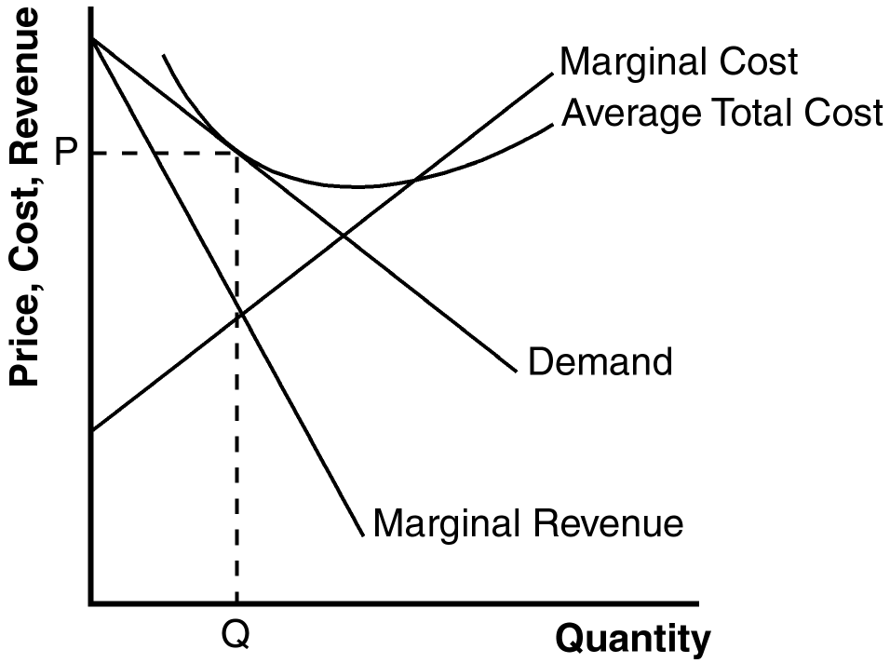

Figure 1

2. Advertising may make markets less competitive because it manipulates people’s tastes rather than being informative. Advertising gives consumers the perception that there is a greater difference between two products than really exists. That makes the demand curve for a product more inelastic, so the firms then charge greater markups over marginal cost. However, some advertising could make markets more competitive, since advertising is just one more method of competition between products and since it sometimes provides useful information to consumers, allowing them to more easily take advantage of price differences. In addition, expensive advertising can be a signal of quality. Advertising also allows entry, since advertising can be used to inform consumers about a new product.

Brand names may be beneficial because they provide information to consumers about the quality of goods. They also give firms an incentive to maintain high quality, since their reputations are important. But brand names may be criticized because they may simply differentiate products that are not really different, as in the case of drugs that are identical but the brand-name drug sells at a much higher price than the generic drug.

Questions for Review

1. The three attributes of monopolistic competition are: (1) there are many sellers; (2) each seller produces a slightly different product; and (3) firms can enter or exit the market without restriction. Monopolistic competition is like monopoly because firms face a downward-sloping demand curve, so price exceeds marginal cost. Monopolistic competition is like perfect competition because, in the long run, price equals average total cost, as free entry and exit drive economic profit to zero.

2. In Figure 2, a firm has demand curve D₁ and marginal-revenue curve MR₁. The firm is making profits because at quantity Q₁, price (P₁) is above average total cost (ATC). Those profits induce other firms to enter the industry, causing the demand curve to shift to D₂ and the marginal-revenue curve to shift to MR₂. The result is a decline in quantity to Q₂, at which point the price (P₂) equals average total cost (ATC), so profits are now zero.

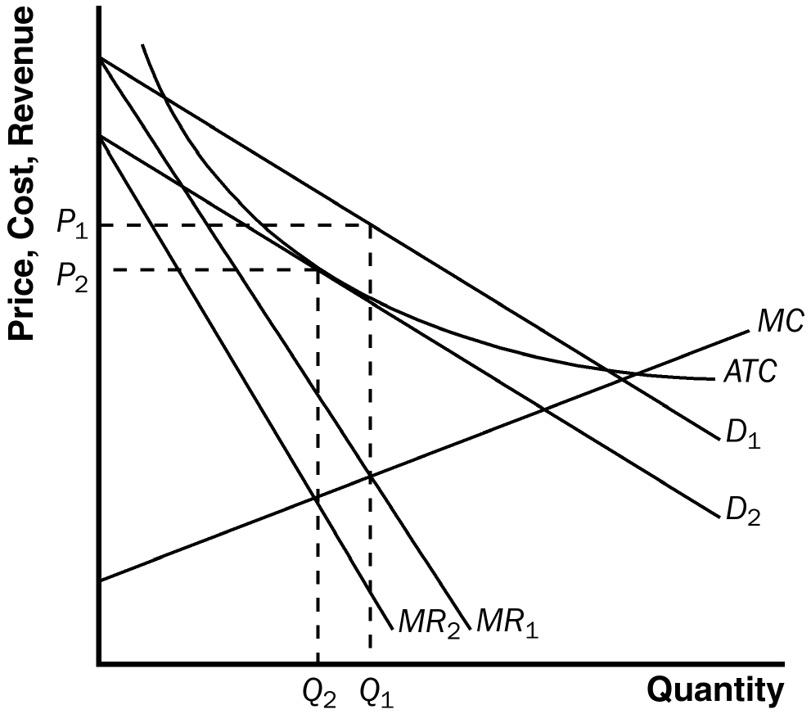

Figure 2

Figure 3

3. Figure 3 shows the long-run equilibrium in a monopolistically competitive market. Price equals average total cost. Price is above marginal cost.

4. Since, in equilibrium, price is above marginal cost, a monopolistic competitor produces too little output. But this is a hard problem to solve because: (1) the administrative burden of regulating the large number of monopolistically competitive firms would be high; and (2) the firms are earning zero economic profits, so forcing them to price at marginal cost means that firms would lose money unless the government subsidized them.

5. Advertising might reduce economic well-being because it is costly, manipulates people's tastes, and impedes competition by making products appear more different than they really are. But advertising might increase economic well-being by providing useful information to consumers and fostering competition.

6. Advertising with no apparent informational content might convey information to consumers if it provides a signal of quality. A firm won't be willing to spend much money advertising a low-quality good, but will be willing to spend significantly more advertising a high-quality good.

7. The two benefits that might arise from the existence of brand names are: (1) brand names provide consumers information about quality when quality cannot be easily judged in advance; and (2) brand names give firms an incentive to maintain high quality to maintain the reputation of their brand names.

Problems and Applications

1. a. The market for #2 pencils is perfectly competitive since pencils by any manufacturer are identical and there are a large number of manufacturers.

b. The market for bottled water is monopolistically competitive because of consumers' concerns about quality. As a result, each producer has a slightly different product.

c. The market for copper is perfectly competitive, since all copper is identical and there are a large number of producers.

d. The market for local telephone service is monopolistic because it is a natural monopoly—it is cheaper for one firm to supply all the output.

e. The market for peanut butter is monopolistically competitive because different brand names exist with different quality characteristics.

f. The market for lipstick is monopolistically competitive because lipstick from different firms differs slightly, but there are a large number of firms who can enter or exit without restriction.

2. A monopolistic firm produces a product for which there are no close substitutes, but a monopolistically competitive firm produces a product that is only somewhat different from substitute goods. So the goods differ in terms of the degree to which substitutes exist.

3. Monopolistically competitive firms don't increase the quantity they produce to lower the average cost of production because doing so would require them to lower their price. The loss in revenue from the lower price outweighs the benefits of the lower cost of production.

4. a. Figure 4 illustrates the market for Sparkle toothpaste in long-run equilibrium. The profit-maximizing level of output is Q_{M} and the price is P_{M}.

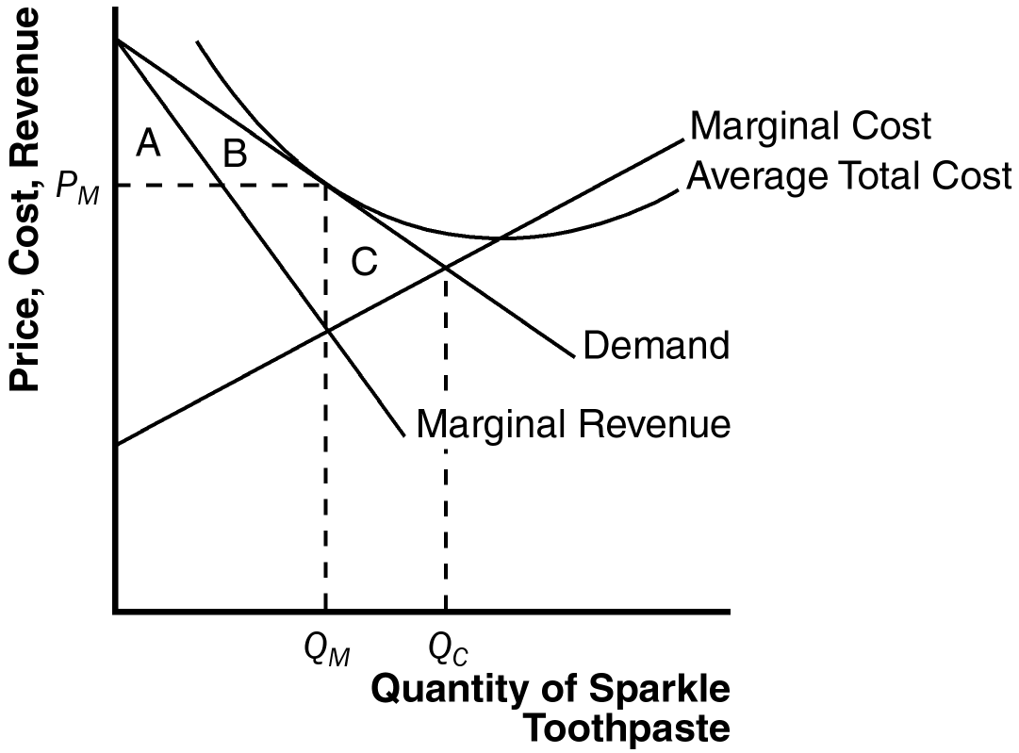

Figure 4

b. Sparkle's profit is zero, since at quantity Q_{M}, price equals average total cost.

c. The consumer surplus from the purchase of Sparkle toothpaste is area A + B. The efficient level of output occurs where the demand curve intersects the marginal-cost curve, at Q_{C}. So the deadweight loss is area C, the area above marginal cost and below demand, from Q_{M} to Q_{C}.

d. If the government forced Sparkle to produce the efficient level of output, the firm would lose money because average cost would exceed price, so the firm would shut down. If that happened, Sparkle's customers would earn no consumer surplus.

5. Since each firm in a monopolistically competitive market produces a product that is slightly different from other products, a monopolistically competitive market has a large number of products. But whether that number is optimal or not depends on two key externalities: the product-variety externality and the business-stealing externality. The product-variety externality is a positive externality to consumers from the introduction of a new product. The business-stealing externality is a negative externality because other firms lose customers and profits from the addition of a new product. Since the entrant doesn't take these externalities into account in deciding whether or not to enter the market, it isn't clear whether the actual number of products will be optimal, above optimal, or below optimal.

6. By sending Christmas cards to their customers, monopolistically competitive firms are advertising themselves. Since they are in a position in which price exceeds marginal cost, they would like more customers to come in, as shown in Figure 5. Since the price, P_{M}, exceeds marginal cost, MC_{M}, any additional customer who pays the existing price increases the firm's profits.

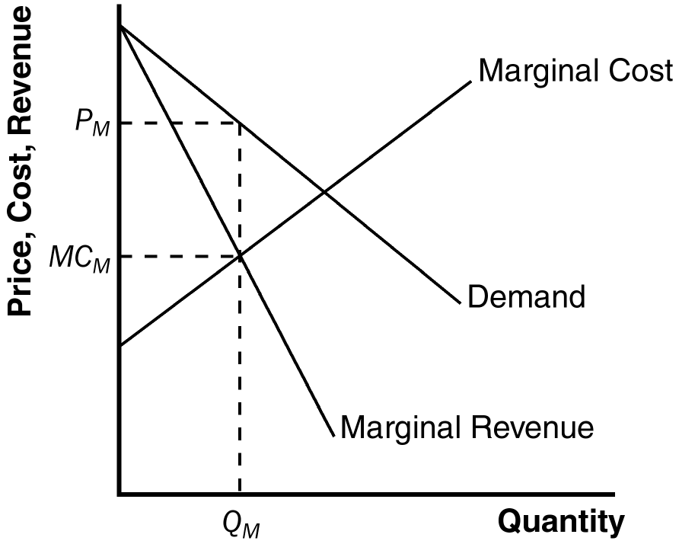

Figure 5

7. If you were thinking of entering the ice-cream business, you would want to make ice cream that is slightly different from the existing brands. By differentiating your product from others, you gain some market power.

8. Many answers are possible. The answers should explain that commercials are socially useful to the extent that they provide consumers information about the product or demonstrate from the existence of the commercial that the product is worth advertising, and thus is not of low quality. Commercials are socially wasteful to the extent that they manipulate people's tastes and try to make products seem more different than they really are.

9. a. A family-owned restaurant would be more likely to advertise than a family-owned farm because the output of the farm is sold in a perfectly competitive market, in which there is no reason to advertise, while the output of the restaurant is sold in a monopolistically competitive market.

b. A manufacturer of cars is more likely to advertise than a manufacturer of forklifts because there is little difference between different brands of industrial products like forklifts, while there are greater perceived differences between consumer products like cars. The possible return to advertising is greater in the case of cars than in the case of forklifts.

c. A company that invented a reliable watch is likely to advertise more than a company that invented a less reliable watch that costs the same amount to make because the company with the reliable watch will get many repeat sales over time to cover the cost of the advertising, while the company with the less reliable watch will not.

10. a. Perdue created a brand name for chicken by advertising. By doing so, he was able to differentiate his product from other chicken, gaining market power.

b. Society gained to the extent that Perdue has a great incentive to maintain the quality of his chicken. Society lost to the extent that the market for chicken became less competitive, with the associated deadweight loss.

11. a. Figure 6 shows Tylenol's demand, marginal revenue, and marginal cost curves. Tylenol's price is P_{T}, its marginal cost is MC_{T}, and its markup over marginal cost is P_{T} - MC_{T}.

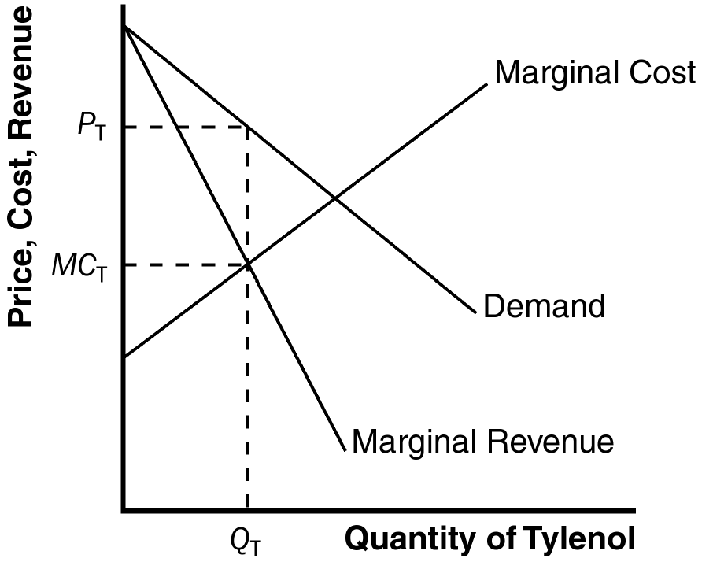

Figure 6

b. Figure 7 shows the demand, marginal revenue, and marginal cost curves for a maker of acetaminophen. The diagrams differ in that the acetaminophen maker faces a horizontal demand curve, while the maker of Tylenol faces a downward-sloping demand curve. The acetaminophen maker has no markup of price over marginal cost, while the maker of Tylenol has a positive markup, because it has some market power.
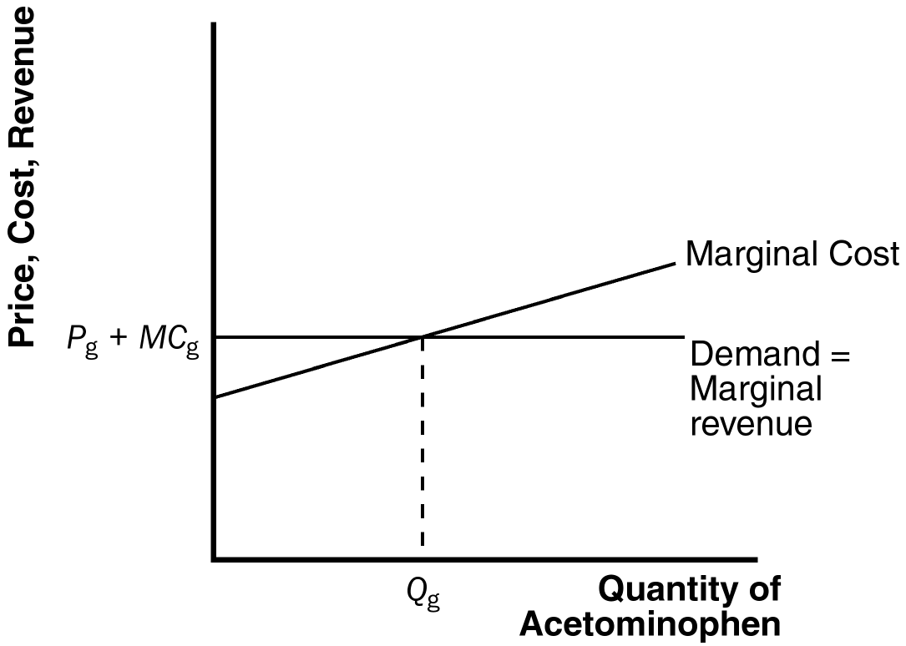

Figure 7

c. The maker of Tylenol has a bigger incentive for careful quality control, because if quality were poor, the value of its brand name would deteriorate, sales would decline, and its advertising would be worth less.

